This QRG outlines the steps to review, edit, and approve calendars created on an individual’s behalf by the business office.

Access the Summer Pay Tool
Visit OneCampus and select SEEMLESS. | https://one.purdue.edu/
Log in using Purdue Career Account Login and Password

Calendar
Once logged in, the Summer Pay Dashboard is displayed. | 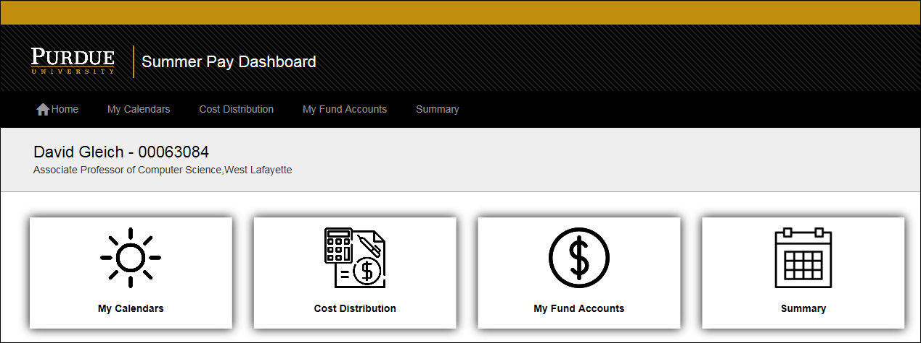
Click My Calendars.
Calendars awaiting review are highlighted in yellow and have a status of Faculty Verification.  Click the Calendar to select and open. | 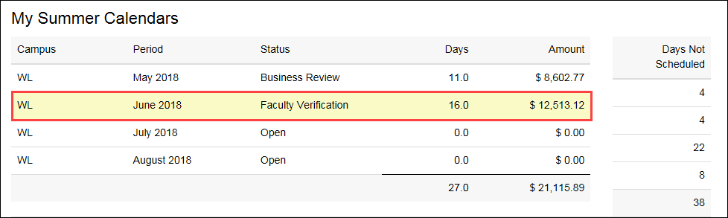
The calendar information is displayed.  Make edits as necessary. | 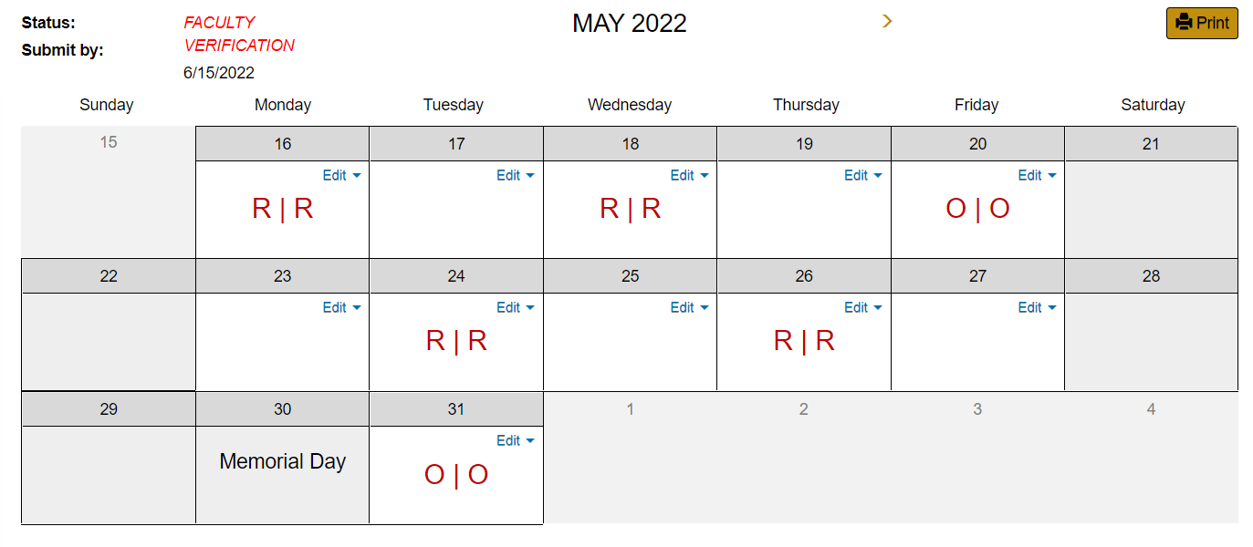
Comments can be entered in the box in the lower left-hand side
Click Review Before Submission.
Changes are highlighted in yellow.  Any change to the Summer Pay calendar requires Business Office review and approval.  If changes have been made,  Click Send for Business Review.  Upon approval from the business office, the finalized calendar will be sent to Payroll for processing. | 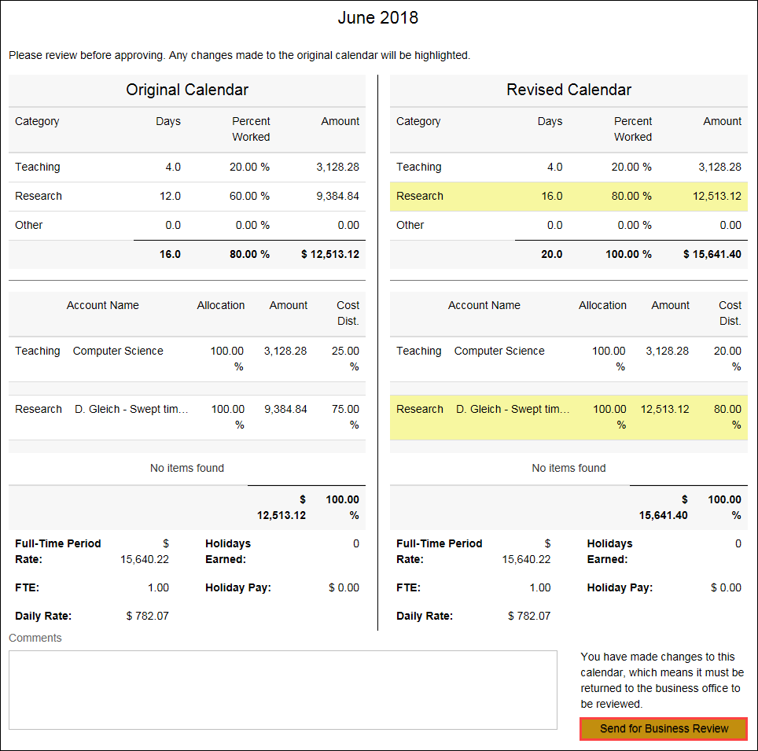
If changes are not made, the calendar can be submitted directly to Payroll by clicking Submit Calendar. | 